 | Assignment No. 1  Semester: Fall 2019  CS201 – Introduction to Programming |  | Total Marks: 20  Due Date: November 14, 2019
Instructions
Please read the following instructions carefully before submitting assignment:
It should be clear that your assignment will not get any credit if:

- Assignment is submitted after due date.
- Submitted assignment does not open or file is corrupt.
- Assignment is copied (From internet/students).

Software allowed to develop Assignment
- Dev C++

Objectives:
To enable students to understand and practice the concepts of:
- Variables and operators
- Loops or repetition structures
- If-else statements
- Functions
- Random number generation
- Control random number in specific range

Assignment Submission Instructions
You have to submit only.cpp file on the assignments interface of CS201 at VULMS. Assignment submitted in any other format will not be accepted and will be graded zero marks.
Please note again, assignment submitted other than .cpp format will get zero marks.

Assignment

Programming is a nice tool which can be used to make our life easier. With the help of programming we can do many things auto generated and efficiency. As a programmer first task of this semester is given to you is develop a console-based application for school teachers. This application will auto generate questions for Grades 1, 2, 3, 4 and 5. Using this application teacher will be able to give different paper to each student.

Assignment Statement:
Write a menu-based program in C++ that will take input from user(teacher) and fulfill following requirements.

- There should be a menu that allow to select grade of class.
- Created questions should be mixed type (addition and subtraction).
- User will give number of questions that will be generated for a paper.
- Ratio of addition and subtraction questions is not fixed. It will random, a paper can have more questions of one type than other. See sample output screenshot.
- Number of minimum and maximum digits in paper of grade 1 will be two.
- Number of minimum and maximum digits in paper of grade 2 will be three.
- Number of minimum and maximum digits in paper of grade 3 will be four.
- Number of minimum and maximum digits in paper of grade 4 will be five.
- Number of minimum and maximum digits in paper of grade 5 will be six.
- Screen shot of required application is given below as simple output.
- Most critical requirement is, the operand (number) on left side of subtraction sign must be larger than the number on right side of sign (operator). This requirement is highlighted in sample screenshot too.
- In case of addition operation, the operand (number) on left side of addition sign can be larger or smaller from the number on right side of sign (operator).

Solution instructions:
- Variables, loops, if-else, rand() function with % operator, functions (one which return a value and one which do not return a value) will help you to solve the problem.
- Use rand() function to generate a random number. You can control the range of number with the help of modulus (%) operator.
- To use rand() function you must include “stdlib.h” header file.
- To control the range of random number rand() % N can help, if value of N will be 100 then range of randomly generated number will be 0 to 99.
- If you want to control the range of random number between 10 to 19 then following formula will help.
  - [10 + rand() % (19 – 10 + 1)]

Sample output:
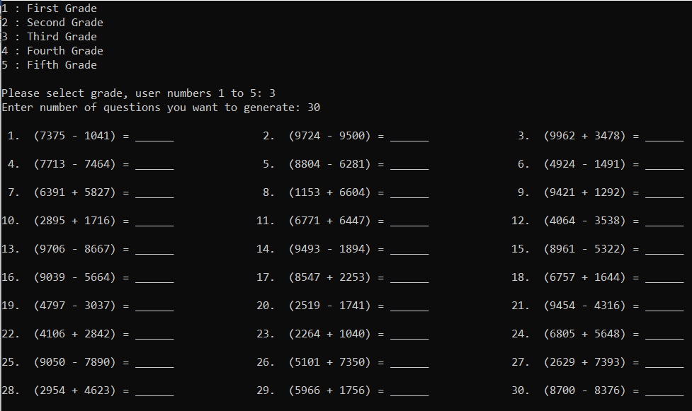
In case of addition number on left side of operator can be smaller than number on right side
In case of subtraction number on left side of operator must be larger than number on right side

Lectures Covered: (Lecture # 1- 10) and Solution Deadline: (November 14, 2019).

